AFL - FATIGUE & RECOVERY
This challenge is simple – Aim to complete questions from one or more of the 3 categories below to the value of 10 points.
1 point questions are pretty easy, 2 point questions require more thought, and……………….
3 pointers get you thinking the most.
It’s up to you - do questions from all of the categories, or simply do them from two :
At the end 10 points is your aim!

1. Provide a one sentence definition of “fatigue”  2. Fatigue is often referred to as being “multi-factorial” – use your own words to describe what this means.  - Some students believe an “active recovery” involves performing a set of stretches and a slow jog after training or competition have been completed. Provide a better definition of an “active recovery”.  - Create a table which reveals the most common causes of fatigue and the recommended recovery strategy to counter this cause, e.g.  - When AFL players switch to fats as their main fuel source they “slow down” – why? | 1 Point each
  Major Cause of Fatigue | Most Effective Recovery Strategy
- How does the accumulation of H+ ions lead to performance decrements/fatigue?  7. Many “explosive” AFL players who have great speed and power still undertake lots of aerobic training during the pre-season preparation and also in-season training. Why would they do this even though their aerobic energy system is often not the most predominant one during games?  8. If an AFL player is rapidly using his carb stores during a game, discuss two strategies either during the game or breaks that can be used to “refuel” and “top-up” carbohydrate stores.  9. Discuss the advantages an active recovery has over a massage applied to an AFL player by a sports masseur, other than promoting blood flow to and from working muscles. | 2 Points each
10. a. How does an elevated body temperature result in less oxygen and nutrients being transported to working muscles?  b. What can AFL players do to ensure they don’t experience elevated body temperatures to the point of it causing them to fatigue?  11. Describe three benefits sports drinks containing electrolytes provide players who consume them in terms of countering fatigue.  12. List two differences between consuming carbohydrates and proteins during recovery by completing the following Venn diagram (similarities are central).  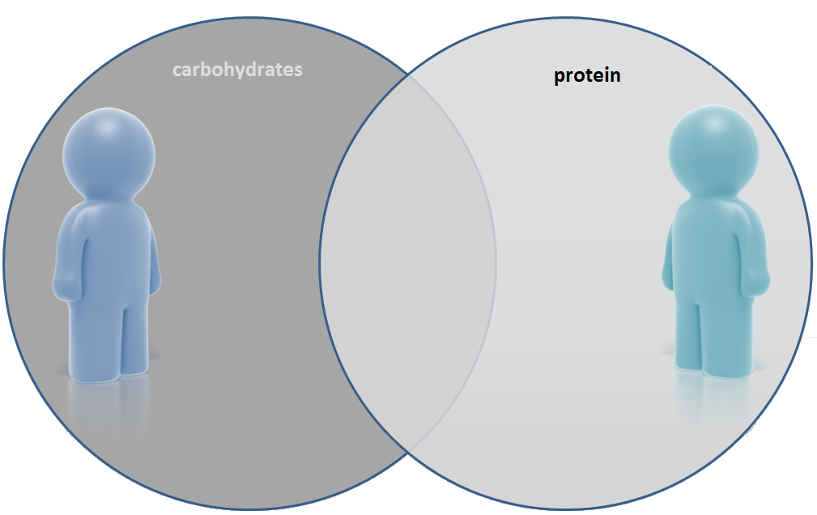 | 3 Points each

